JULY 2023

3 Mad Scientist Monday  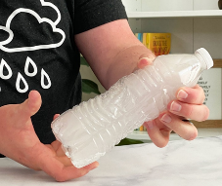 | 4 HOLIDAY | 5 Movie Day @ Cinemark | 6 Nature Discover Center | 7 Splash Day  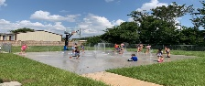
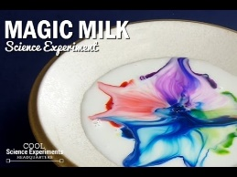  10 Mad Scientist Monday | 11 Obstacle Course | 12 Movie Day @ Cinemark | 13 Downtown Aquarium  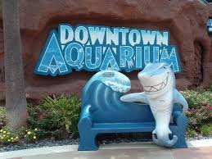 | 14 Splash Day  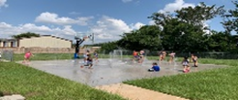
17 Mad Scientist Monday | 18 Art Camp: STEAM | 19 Movie Day @ Cinemark | 20 It’z Pizza | 21 Splash Day
24 Mad Scientist Monday | 25 Sand Painting  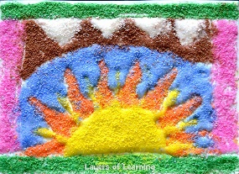 | 26 Movie Day @ Cinemark | 27 Kids Backporch Productions “Newsies”  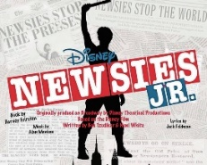 | 28 Splash Day

