JUNE 2023

29 Holiday | 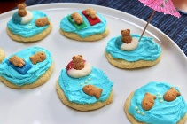  30 Cookie Decorating | 31 Tennis  @ Texas Avenue Park | 1 Bayou Wildlife Zoo  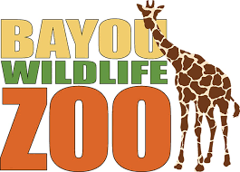 | 2 Splash Day  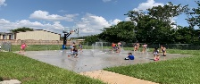
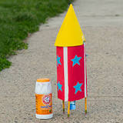  5 Mad Scientist Monday | 6 Foam Party | 7 Volleyball  @ El Franco Lee Park  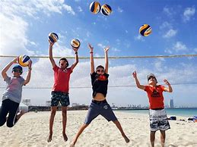 | 8 Lone Star Flight Museum | 9 Splash Day  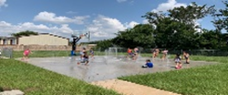
12 Mad Scientist Monday  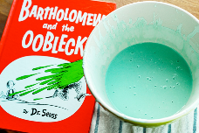 | 13 Sand Art  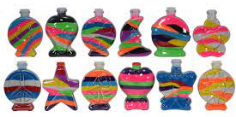 | 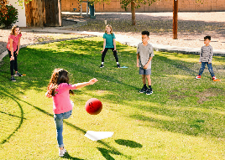  14 Kickball @ Pecan Park | 15 The Play Space | 16 Splash Day
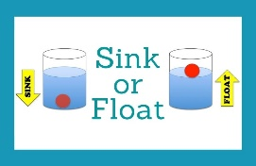  19 Mad Scientist Monday | 20 Kid Creation:  Plaster Painting  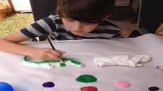 | 21 Movie Day @ Cinemark | 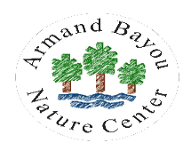  22 Armand Bayou | 23 Splash Day
26 Mad Scientist Monday  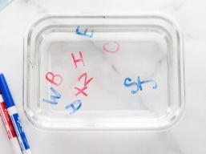 | 27 Tie-Dye T-Shirts | 28 Movie Day @ Cinemark | 29 Urban Air | 30 Splash Day

