August 2023

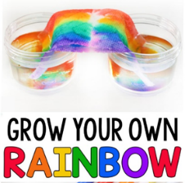  31 Mad Scientist Monday | 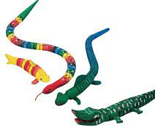  1 Kid Creation: Wiggles | 2 Movie Day @ Cinemark | 3 Chuck E Cheese  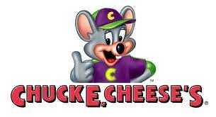 | 4 Splash Day  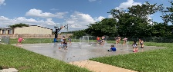
7 Mad Scientist Monday  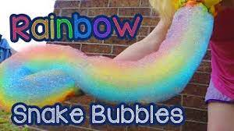 | 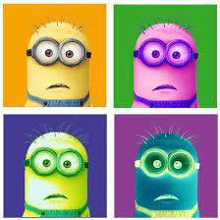  8 Art Camp: Minion Painting | 9 Movie Day @ Cinemark | 10 Jumping World | 11 Last Splash Day &  Pizza Party & Italian Ice Day
14 Pasadena ISD  First Day of School | 15 | 16 Deer Park ISD  First Day of School | 17 | 18
21 | 22 | 23 | 24 | 25

